Name: Mahmoud Mostafa Tayee.

C project Udacity, FWD

Payment Application

# Create modules folders

# Create .c and .h file for each module

## 2.1 Application module

## 2.2 Card module

## 2.3 Server module

## 2.4 Terminal module

# Add header file guard:

## 3.1 Application file guard

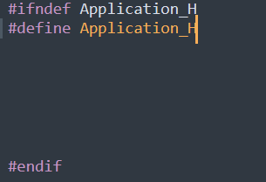

## 3.2 Card file guard

## 3.3 Terminal file guard

## 3.4 Server file guard

The Card module

# Fill in card.h file with functions' prototypes and typedefs:

# Implement getCardHolderName function:

## 5.1 The test function:

## 5.2 the results on the console.

# Implement getCardExpiryDate function.

## 6.1 The test function:

## 6.2 The results on the console.

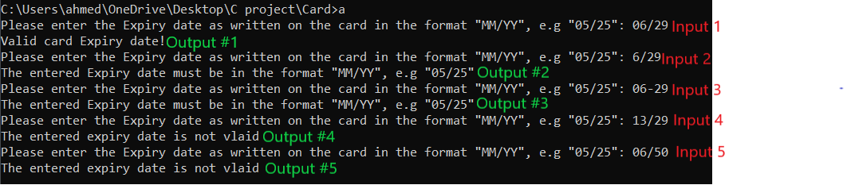

# Implement getCardPAN function

## 7.1 The test function.

## 7.2 The results on the console.

The Terminal module

# Fill in terminal.h file with functions' prototypes and typedefs

# Implement getTransactionDate function

## 9.1 The test function



## 9.2 he results on the console.



# Implement isCardExpried function

## 10.1 the test function

## 10.2 the results on the console.

# Implement getTransactionAmount function

## 11.1 the test function

## 11.2 The results on the console.

# Implement isBelowMaxAmount function

## 12.1 The test function

## 12.2 The results on the console.

# Implement setMaxAmount function.

## 13.1 the test function

## 13.2 The results on the console.

The Server module

# Fill in terminal.h file with functions' prototypes and typedefs

# Implement server-side accounts' database.

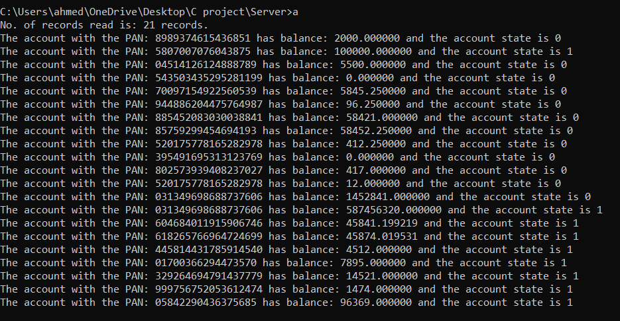

# Implement server-side transactions' database.

# Implement recieveTransactionData function

## 17.1 The test function.

## 18.2 The results on the console.

# Implement isValidAccount function

## 18.1 The test function.

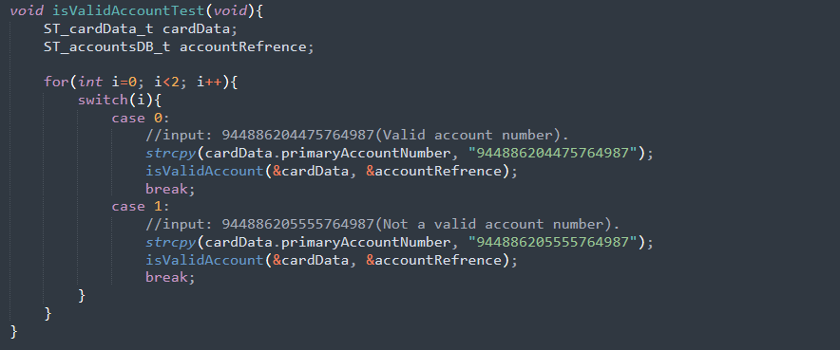

## 18.2 The results on the console.



# Implement isBlockedAccount function

## 19. 1 The test function.

## 19. 2 The results on the console.

# Implement isAmountAvailable function

## 20.1 The test function.

## 20.2 The results on the console.

# Implement saveTransaction function21.1 The test function.

## 21.1 The test function.

## 21.2 The results on the console.

# Implement listSavedTransactions function

## 22.1 The test function.



## 22 .2 The results on the console.

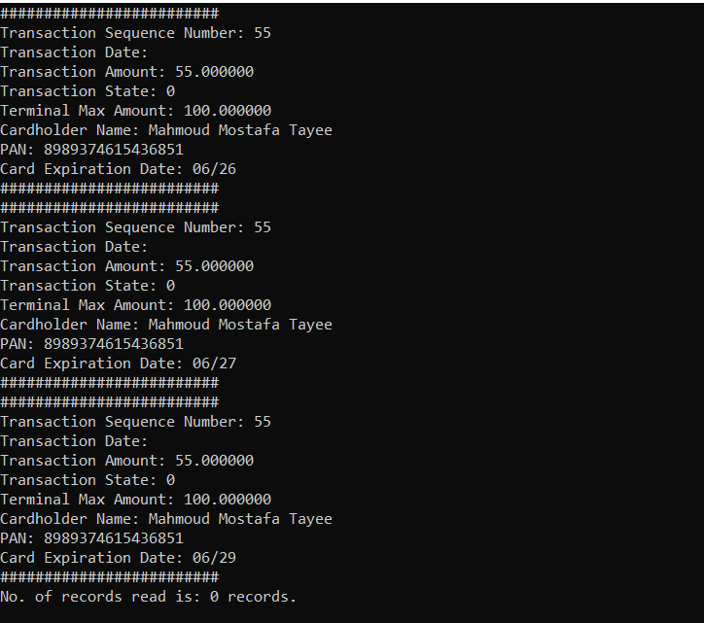

# Fill in application.h file with functions' prototypes

